Knowledge Organiser

Year Group: Year 3/4 Term: Spring Academic Year: 2023/2024
Subject: Science Topic: Sound

What I should already know?
In KS1 children:
• May have some understanding that objects make different sounds.
• Some understanding that they use their ears to hear sounds.
• Know about their different senses.

What will I know by the end of this unit?
- Sound travels from its source in all directions and we hear it when it travels to our ears.
- Sound travel can be blocked. · Sound spreads out as it travels.
- Changing the shape, size and material of an object will change the sound it produces.
- Sound is produced when an object vibrates.
- Sound moves through all materials by making them vibrate.
- Changing the way an object vibrates changes it’s sound.
- Bigger vibrations produce louder sounds and smaller vibrations produce quieter sounds.
- Faster vibrations (higher frequencies) produce higher pitched sound
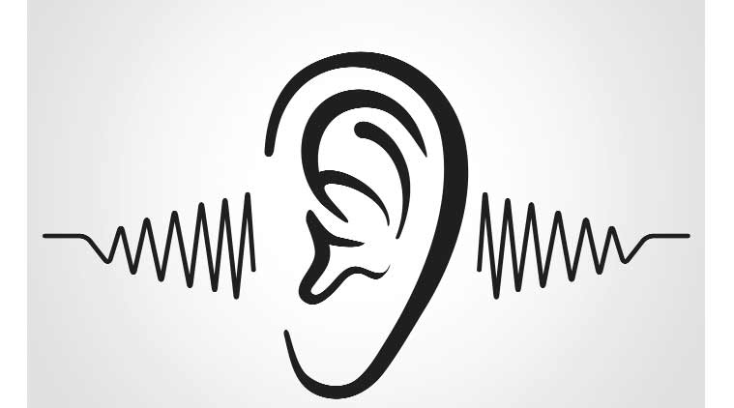

Vocabulary – You need to be able to understand and be able to use these words by the end of this unit
Vibration - move side to side quickly with small movements | Pitch (high, low) - how high or low a sound is
Medium - a substance that makes possible the transfer of energy from one location to another | Volume - the amount of sound produced
Auditory- related to sound | Absorb - soaked into
Soundproof - to stop sound | Produce - cause a particular result or effect
decibel- measure of sound | Source - the origin of something
Particle - minute portion of a matter | Wave - up and down movement of particles

